Template for Preparation of Manuscript
First name LAST NAME ¹, First name LAST NAME ², …
¹ Company, City, Country, e-mail
² Company, City, Country, e-mail
Abstract. Lorem ipsum dolor sit amet, consectetur adipiscing elit. Vivamus euismod leo sed enim iaculis dignissim. In sapien arcu, auctor vitae ex ac, tincidunt sodales purus. Nulla et interdum purus, sed consequat erat. Suspendisse bibendum sodales leo id fermentum.
Maecenas pretium, libero vitae tristique cursus, dolor risus egestas magna, non rutrum dolor dui eu lorem. Mauris convallis, lectus sit amet tincidunt euismod, tortor nulla placerat risus, at suscipit diam erat in lacus. Nullam ut felis et massa auctor cursus ac id diam. Lorem ipsum dolor sit amet, consectetur adipiscing elit.
Vivamus euismod leo sed enim iaculis dignissim. In sapien arcu, auctor vitae ex ac, tincidunt sodales purus. Nulla et interdum purus, sed consequat erat. Suspendisse bibendum sodales leo id fermentum. Maecenas pretium, libero vitae tristique cursus, dolor risus egestas magna, non rutrum dolor dui eu lorem.

Keywords:

Introduction
It is important that you realize that the full paper submitted will not be modified by the proceedings’ editor. It will be identical to the final, published version that appears in the proceedings. The volume of the paper should be about 8 pages.

1. Typographical Style and Lay-Out

1.1 Type Area
Always use paper of A4 size. The type area is 15.6 cm wide and 25.2 cm high. This area must be used to the maximum, and at the same time must not be exceeded. The following margin settings in MS Word will produce the correct result, for A4 size paper: top 2.5 cm; bottom: 2 cm; left and right: 2.7 cm.

1.2 Font
The required font for running text is 12 point Times New Roman. For lettering in tables and figures you may use Helvetica or Arial.
Use bold for paragraph headings and italics for subheadings. For font sizes, see Table 1.
Table 1. Required Font Size
20 point | 12 point | 10 point | 8 or 10 point
- paper title | - body text  - authors’ names and affiliations  - paragraph (sub-) headings | - contact e-mail  - abstract  - keywords  - references  - captions and legends of figures and tables | - lettering in figures

1.3 Title Page
Leave a space of 4 cm on the title page blank. Type the title, leave a space of 1 cm and type your data and data of your co-authors as indicated on first page. Use capital letters for the author’s surname. Please summarise data of authors from the same company. Leave another space of 1 cm and type the abstract at a width of 12 cm, in the centre of the page (indent left and right 1.8 cm). Leave two lines blank before starting the first paragraph.

1.4 General Lay-Outs
- Use single line spacing throughout the document.
- Keep all text aligned justified, and only centre the title, author’s name and affiliation, and captions of figures and tables.
- Start a new paragraph by indenting it from the left margin (also in the abstract and after figures, tables or at the top of a new page), not by leaving a line blank. The first line after a (sub-) heading has to start without indention.

1.4.1 Paragraph (Sub-) Headings
- Keep headings left-aligned.
- Number headings and sub-headings consecutively in Arabic numbers and type them in bold, respectively italics.

1.4.2 References
References to the literature should be mentioned in the main text by an Arabic number in square brackets. Use the Citation-Sequence System and list the numbered references at the end of the paper, under the heading References. Do not leave blank lines.
As regards the content, form and punctuation, if the volume editor has not expressed a preference for one particular style, authors should select the most appropriate style, and use it consistently.

1.4.3 Word Paragraph templates
- This MS Word document is also a MS Word template; it provides paragraph styles for Title, Authors, Abstract, Heading 1-3, Standard (Intended), Enumeration (Bullets) and References. Using these styles will help you to fulfil our requirements.

2. Figures

2.1 General Remarks
- The text should include references to all figures and tables.
- Do not assemble figures and tables at the end of your article, but incorporate them in the text.
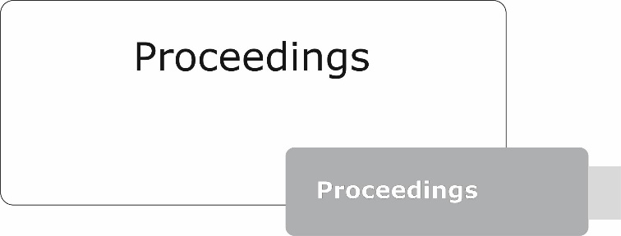
Fig. 1. Figures should be centred on the page.
Centre figure captions below the figure, table captions above the table.

2.2 Format of Figures
- A resolution of 200 dpi should be sufficient.
- Font sizes in figures:
  - the minimum font size for characters in tables is 10 point, and for lettering in figures 8 point.

3. Fine Tuning
- Type area: Do not end a page with one or more blank lines, except to avoid ‘widow’ headings
- Footnotes: Keep footnotes to a minimum, or list them as endnotes before the references.
- Capitalisation: Use initial capitals in chapter titles and headings, with the exception of prepositions, articles and other ‘form-words’, e.g.: “the”, “about” and “in”.

4. Submitting the Full Paper
Please upload a PDF file of your paper. Therefore, please confirm in advance that you have prepared your paper by following the formatting guidelines and that you have checked that formulas, special characters and figures are displayed correctly.
Amendments in title and concerning authors please submit also via the “Edit” function of the contribution service.

References
[1]
[2]

